01:25

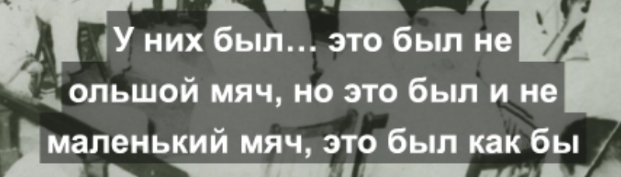

Line 2

Reads: ольшой мяч,

Becomes: большой мяч,